Creation of Azure users and groups and Repo permissions group level and user level
Creation Users:-
Go to Azure DevOps →
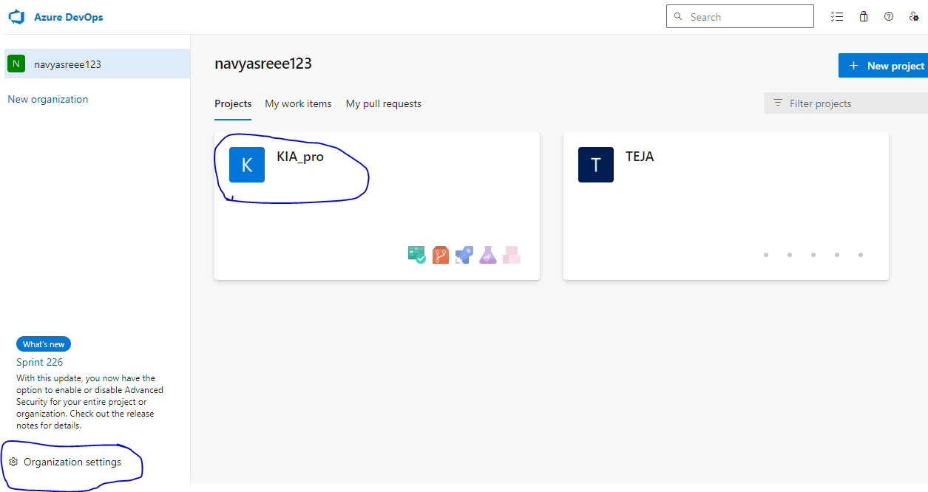
Add User
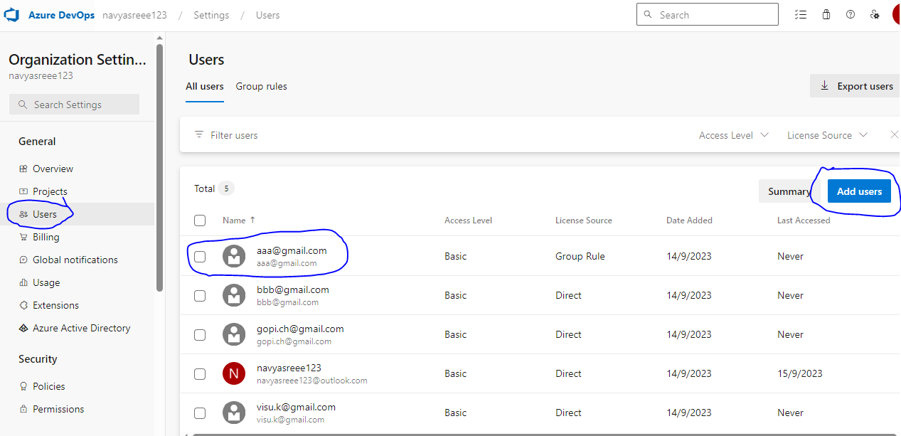

Go to Project Settings..
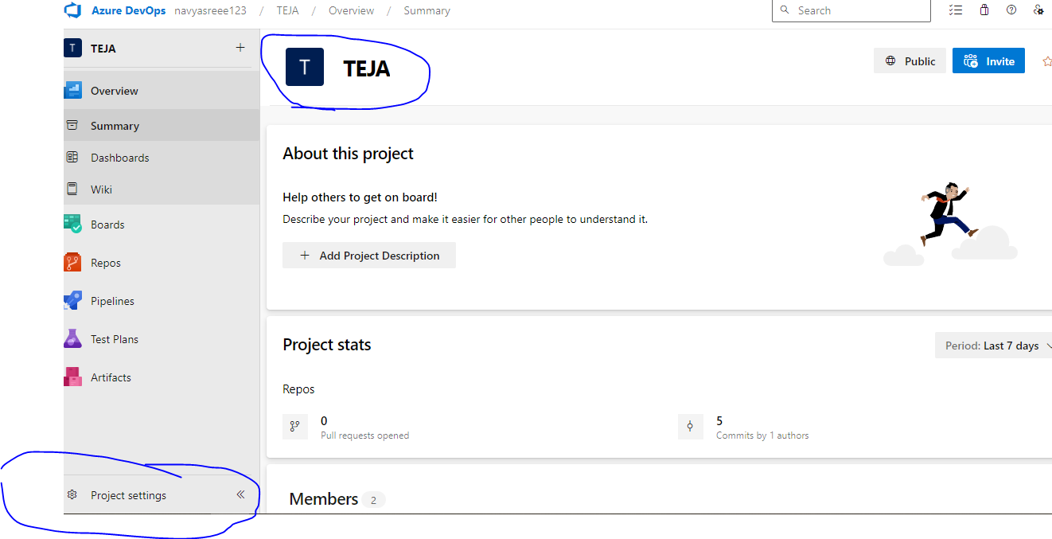

Create Group and add members:- Project settings-permissions-NewGroup- add group here Testing.
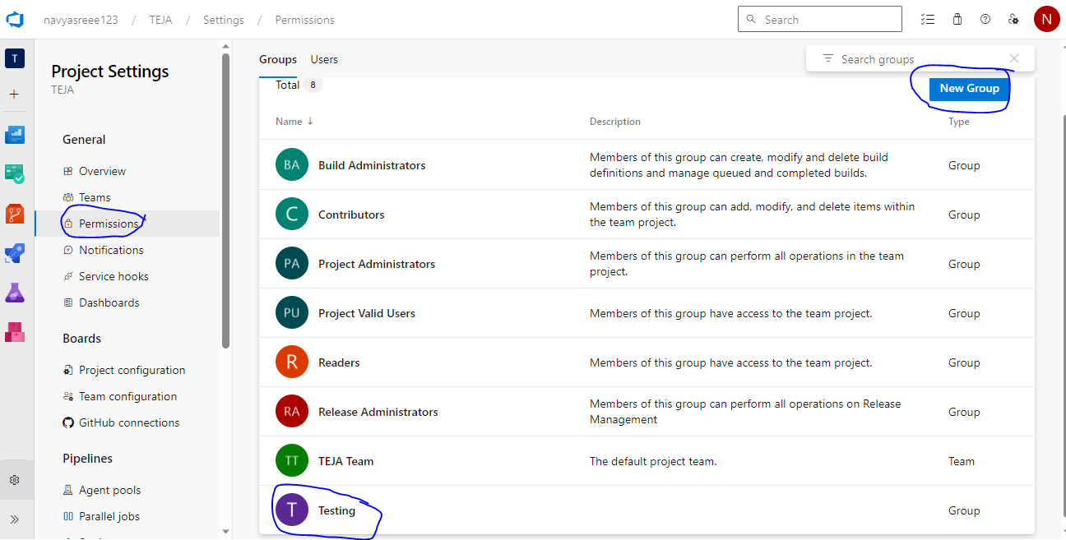

Permission Group wise, For Example Testing group
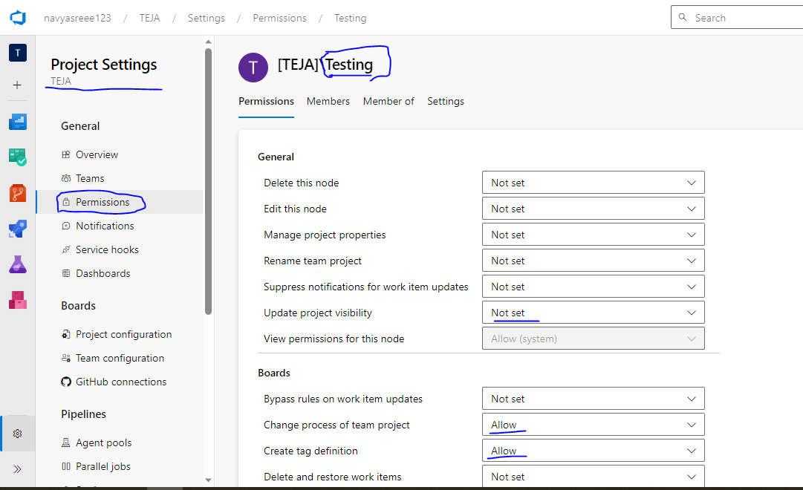

Add members in Group for Example in Testing.(it means all the permissions applied in group members)
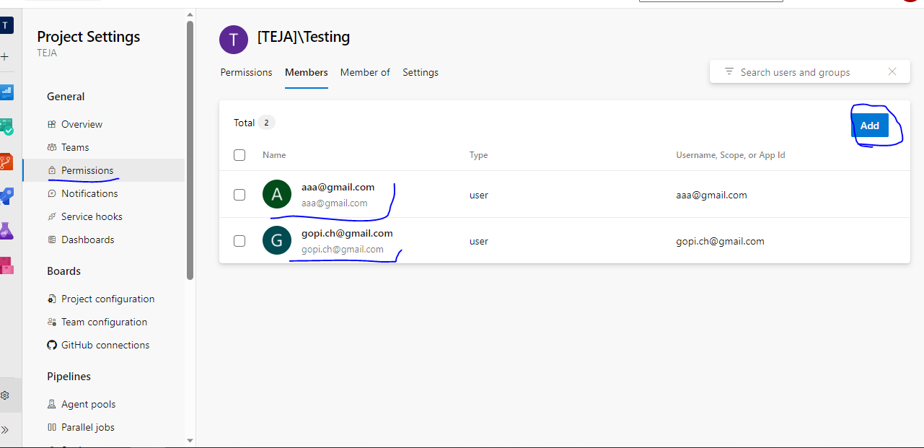

Repo Permission group wise.

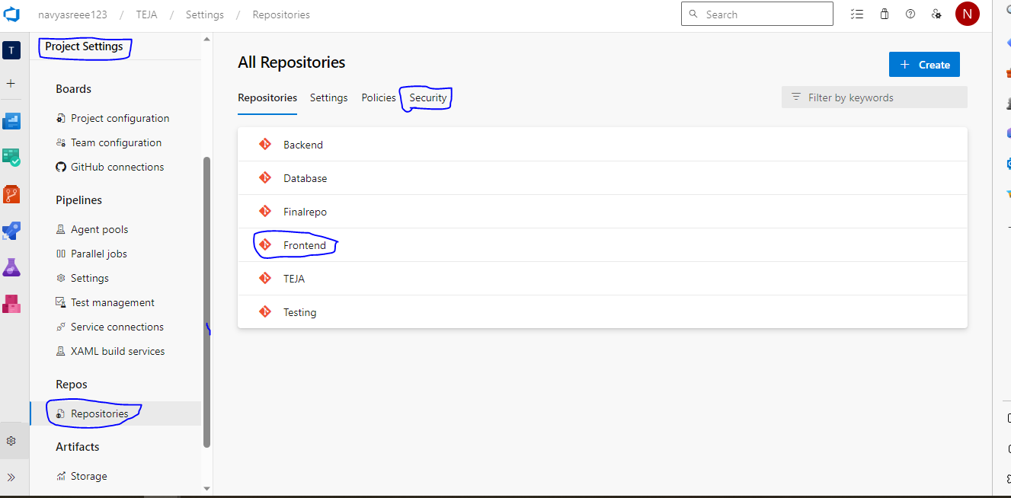

Go to project settings –Repos—select Repo Frontend—security—here we selected Tested group here we have to select permission for example I have selected Contributed Allow, it means in this group all users applied same permission.
If we want special permission any user we can provide here, in search box enter user name and provide allow the particular access here.
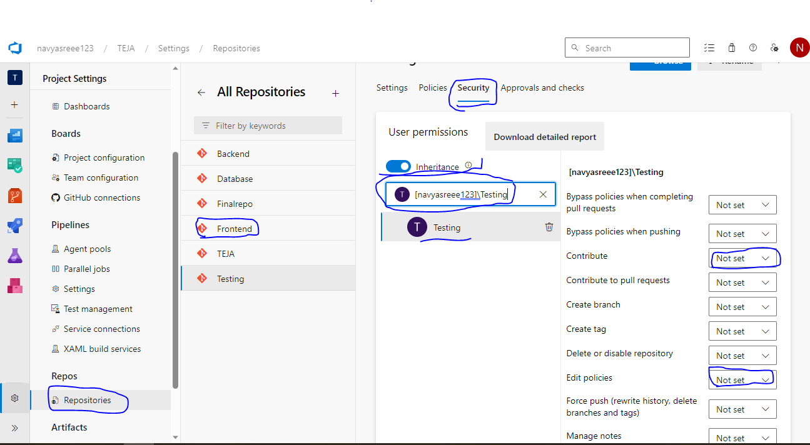

Branch level permissions:_ go to repositories select-repository here I select →IagriAutomation->click policy→down side branch policy→select branch→ here we have give permission (Contribute).

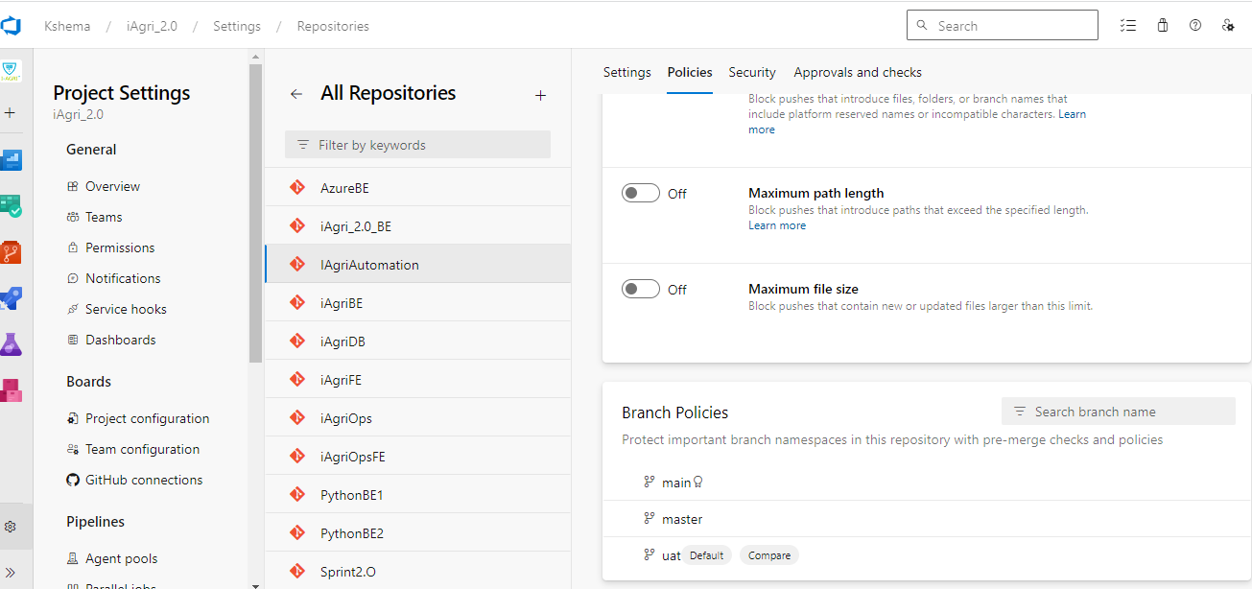

For Oficial Documents:_ https://learn.microsoft.com/en-gb/azure/devops/pipelines/get-started/pipelines-sign-up?view=azure-devops

Azure DevOps Tutorial - A Step-by-Step Guide for Beginner's (intellipaat.com)

